1. Report No: 3
2. Report Date:12/01/2019
3. Project Title: Face Recognition
4. Company Name: MSBC Solutions (India) Pvt. Ltd.
5. Tools/Technologies: Python , Flat Database
6. Work Done: 1. SRS(Software Requirement Specification)
7. Submitted By: Mit Patel(MA033)

Meet Shah (MA043)

1. Remarks (External Guide), if any
2. Remarks (Internal Guide), if any

**Internal Guide: External Guide:**

Dr. Narayan Joshi Mr. Anish Mathur

Head of Department Team Manager

**Software Requirement Specification:**

**Functionalities**

**Project Title: Face Recognition**

**INTRODUCTION:**

**Purpose:**

Purpose of Building Face Recognition System is for the identifying the faces from image capturing devices or from the images and videos.

**Scope:**

There are some scope for the current system to which solutions can be provided as a future

Development:

1. Image quality affects how well facial-recognition algorithms work. The image quality of scanning video is quite low compared with that of a digital camera.

2. When a face-detection algorithm finds a face in an image or in a still from a video capture, the relative size of that face compared with the enrolled image size affects how well the face will be recognized. An already small image size, coupled with a target distant from the camera, means that the detected face is only 100 to 200 pixels on a side. Further, having to scan an image for varying face sizes is a processor-intensive activity

3. The relative angle of the target’s face influences the recognition score profoundly. When a face is enrolled in the recognition software, usually multiple angles are used (profile, frontal and 45-degree are common). Anything less than a frontal view affects the algorithm’s capability to generate a template for the face. The more direct the image and the higher its resolution, the higher the score of any resulting matches.

4. Ironically, humans are vastly superior to technology when it comes to facial recognition. But humans can only look for a few individuals at a time when watching a source video. A computer can compare many individuals against a database of thousands.

5. As technology improves, higher-definition cameras will become available. Computer networks will be able to move more data, and processors will work faster. Facial-recognition algorithms will be better able to pick out faces from an image and recognize them in a database of enrolled individuals. The simple mechanisms that defeat today’s algorithms

6. An immediate way to overcome many of these limitations is to change how images are captured. Using checkpoints, for example, requires subjects to line up and funnel through a single point. Cameras can then focus on each person closely, yielding far more useful frontal, higher-resolution probe images. However, wide-scale implementation increases the number of cameras required.

**Objectives of the System Development**

The basic aim of this research study is to design an effective and secure technique for personal authentication and also evaluate the performance of the designed framework by comparing the performance of existing recognition system. The study also provides the iris template security mechanism to secure iris recognition system.

The reason behind on this demand for the replacement of old-fashioned automatic personal identification tools by new one. The old-fashioned automatic personal identification tools uses traditional approaches such as Personal Identification Number (PIN), Login Id, ID card, password etc. to verify the cognizance of a person, are no longer considered as credible adequate to gratify the security concern for person identification system.

**Goals of implementation:**

The goal of this system is to tackle these problems in an effective and optimal manner by:

* Make the system user-friendly by providing an intensive user interface.
* Easy access through queries and reports for the administration department.
* Restricted data access to user thus providing additional security to data.
* Provide the security implementation system to the user.

**Intended Audience and Users:**

* The user of the System are:
  + Admin
  + User

**Overview:**

**Environmental Characteristics:**

* **Hardware :**
  + Processor: Pentium processor of 400MHz or Higher
  + RAM : Minimum 64GB primary memory
  + Hard disk: Minimum 1GB Hard Disk
  + Monitor : Preferably Color Monitor
  + Web Camera
  + Compact Disk Drive
  + A keyboard and mouse
* **Software:**

Text editor: Jupyter,ipython.

Database: Flat Files or Training Datasets

OS: Any

**Feasibility Study**

Feasibility Study is the measure of how beneficial the development of information system will be to an organization. The feasibility analysis is categorized under four different types.

* Operational Feasibility
* Technical Feasibility
* Schedule Feasibility
* Economic Feasibility

**Operational Feasibility:**

The system will provide advantageous and reliable services to user. The system can be run within suitable environment, system will do operation under environment of limited resources.

Proposed system can support all type of users, who has limited knowledge in computing why because the system provides a user interactive GUI created by using simple language. This is just a thing to install the software on the system, and then it’s a matter of going through each area of the software that you want to control.

**Technical Feasibility:**

There may be a number of technical issues, which are generally raised during the feasibility stage of the investigation. Programming languages, other hardware and software Specifications are easily available for this system development. Hence the proposed system is technically feasible. The considerations that are normally associated technical feasibility include.

- Development Risk.

- Resource Availability.

- Technology.

It is planned to implement the system using Jupyter, Window 10 Operating system, Flat Files or Trained Datasets.

Definitely these tools and technology has fully development and maintenance for this project in today and future in development and modifying. All tool done different work like jupyter used for built a basic structure of this system, python used for different alert and development, flat files or some trained data are used as a datasets for the face recognition system.

**Schedule Feasibility:**

Schedule feasibility corresponds to whether sufficient time is available to complete the project.

For the development of our face recognition project we have sufficient time to develop and publish to the server We give time round about 4 month for the development of this project. How much time on every task is spent shows on this Gantt chart.

**Economic Feasibility**:

The proposed system insures very low cost for the development and implementation. The system can work on systems with a configuration and connectivity which causes no excessive cost for implementation or usage.

Data charge is the only cost that incurred once the software is installed on the system. The study is carried out to check the economic impact that the system will have on the organization.

The system being developed is economic with respect to face recognition system of view. It is cost effective is the sense that has eliminated the paper work completely.

Thus the developed system as well within the budget and this was achieved because Most of the technologies used are freely available.

**Functional Requirements:**

* 1. **Admin:**
* Admin can update the datasets so System can identify the specific face identification from the image or from video source.
* Manage Users: Admin can manage user. Add user, Remove user.
* Maintenance: Admin handle the whole system so other maintenance are required for the system like stock handling, employee salary and many others are required.
* Housekeeping Module: This module deals with backing up of data for future references and hence to reduce the database size

**2. User:**

* User can identify their face by using
  + Own Images
  + From the webcamera

**Non Functional Requirements:**

**Safety Requirements**

There are several user levels in face recognition system, Access to the various subsystems will be protected by a user details. This gives different views and accessible functions of user levels through the system. Maintaining backups ensure the system database security. System can be restoring in any case of emergency.

**Other Requirements**

# When the system is completely developed and submitted to the client, few sessions will be required to make the users of the system understand about the functionality of it and some time to adapt to the system. After those sessions, it’s required that a member from the development team should spend some time in the system background for an agreed time period. That time period will be used in identifying new bugs that could not be reached in the earlier phases of the development process.

**Performance:**

The system must be interactive and the delays involved must be less .So in every action- response of the system, there are no immediate delays. In case of opening windows forms, of popping error messages and saving the settings or sessions there is delay much below 2 seconds, In case of opening databases, sorting questions and evaluation there are no delays and the operation is performed in less than 2 seconds for opening ,sorting, computing, posting> 95% of the files. Also when connecting to the server the delay is based editing on the distance of the 2 systems and the configuration between them so there is high probability that there will be or not a successful connection in less than 20 seconds for sake of good communication.

**Reliability:**

As the system provide the right tools for discussion, problem solving it must be made sure that the system is reliable in its operations and for securing the sensitive details.

**Usability:**

As the system is easy to handle and navigates in the most expected way with no delays. In that case the system program reacts accordingly and transverses quickly between its states.

**Image Formation:**

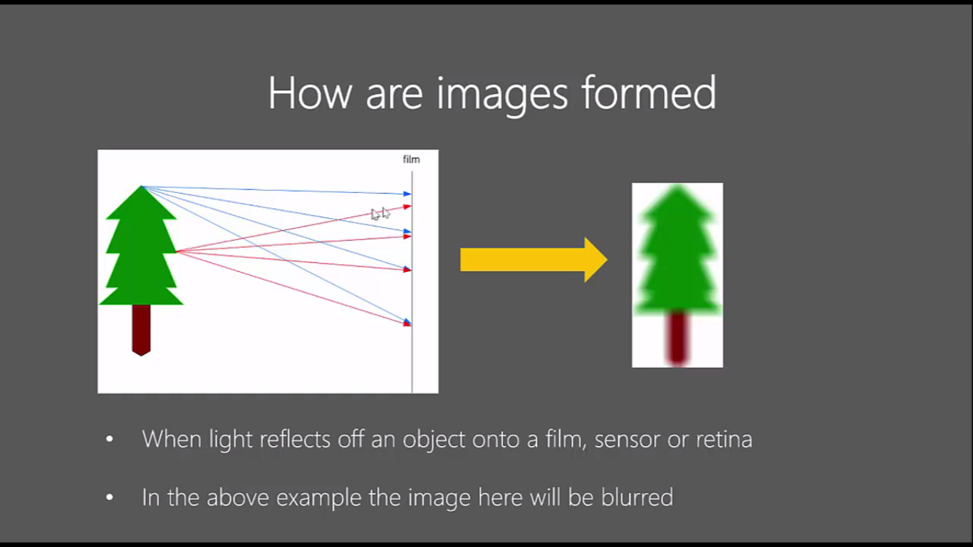

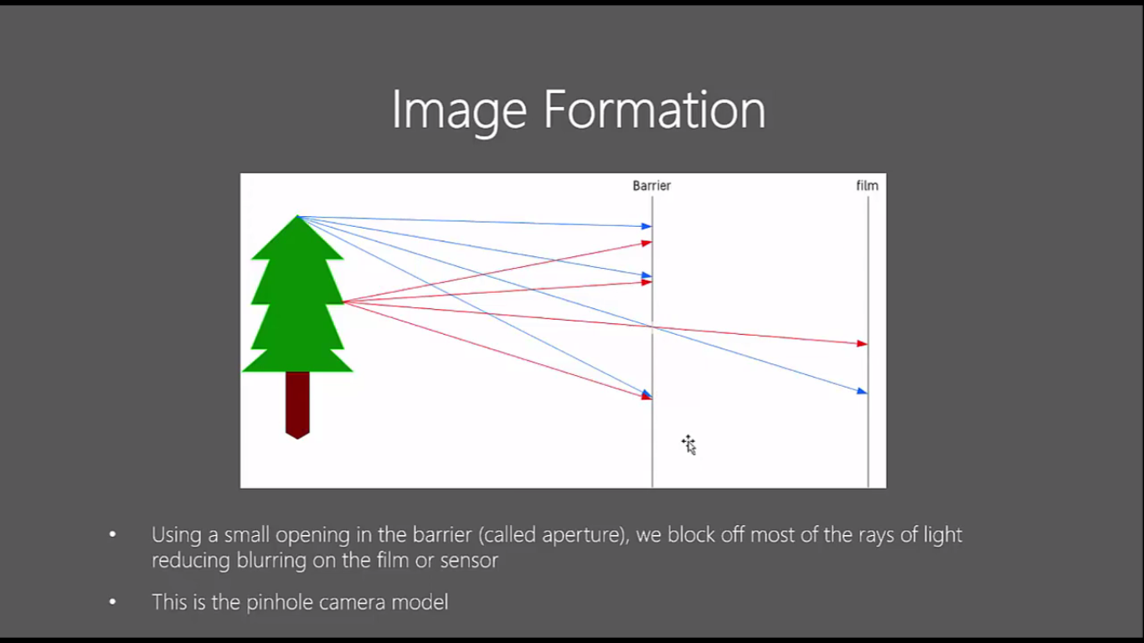

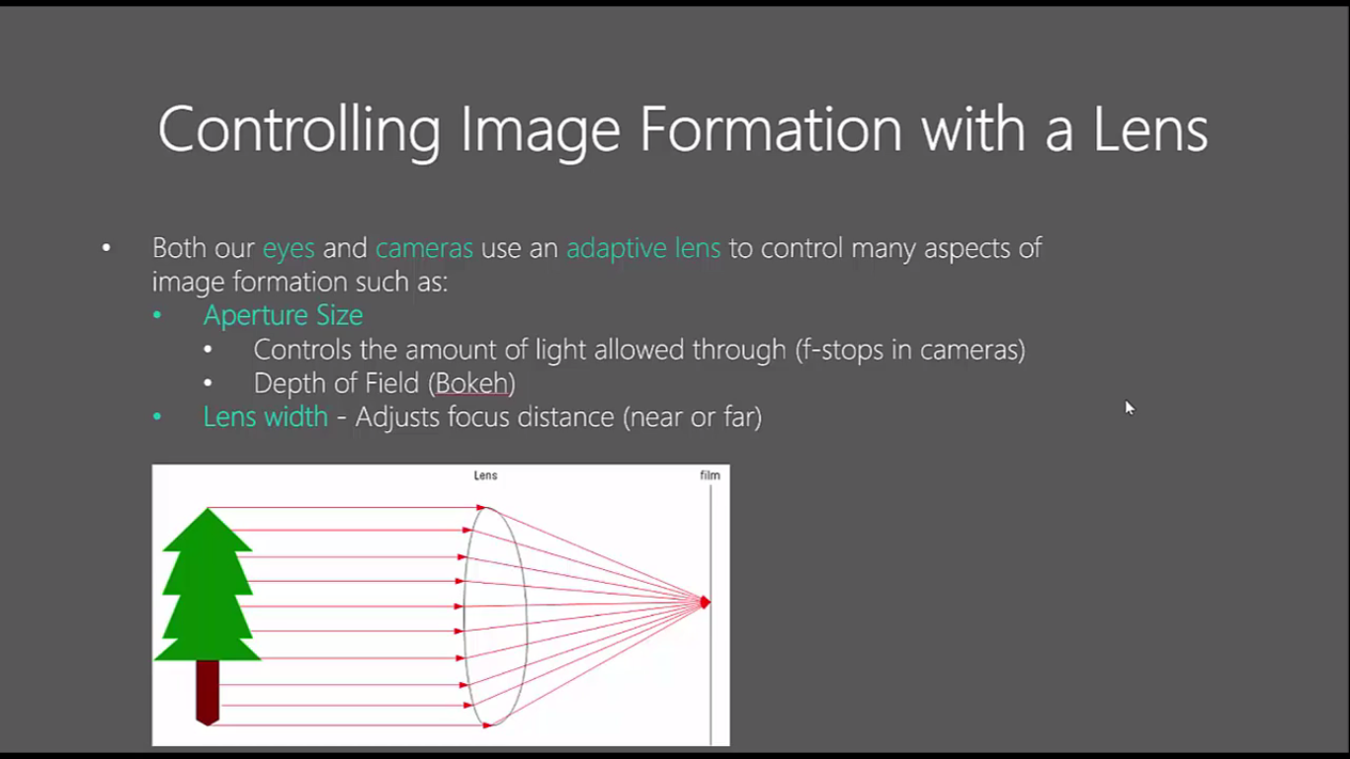

**Differences of image, photo and images**

**Image:**   
Image is the picture which are saved in electronic form e.g. in our phone's gallery.

2-Dimesional Representation of visible light spectrum.

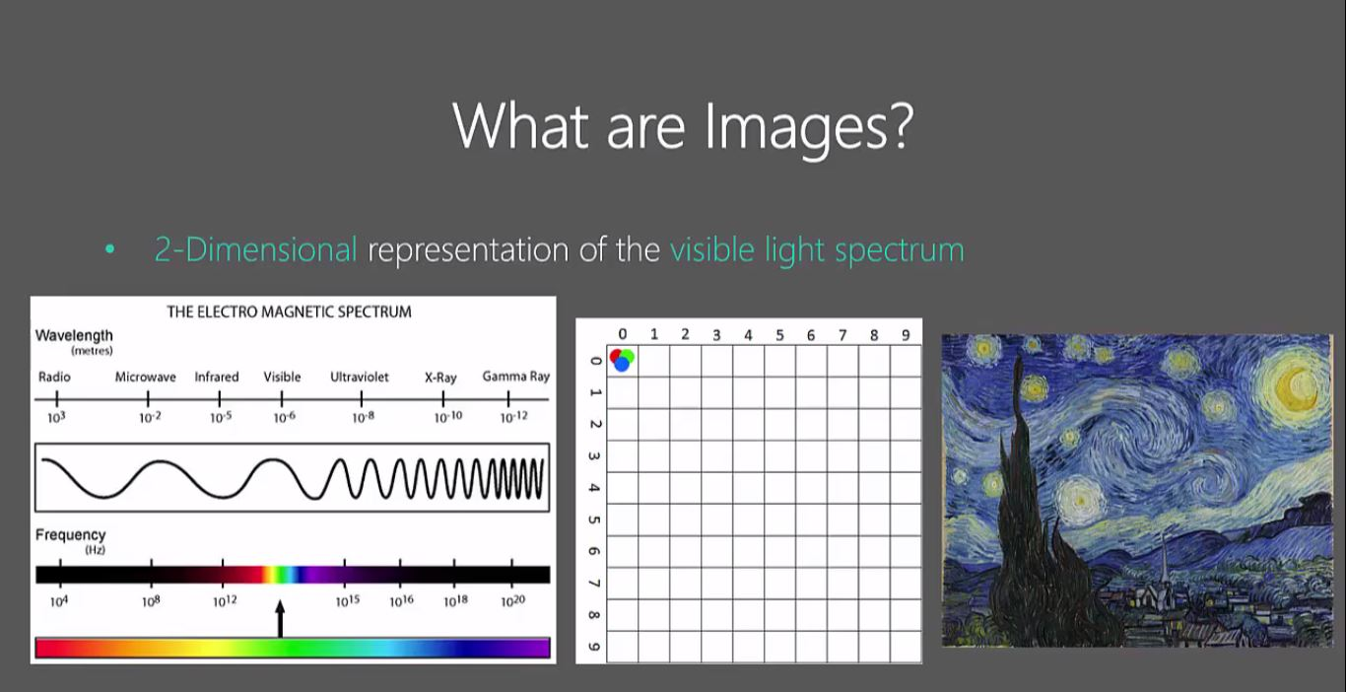  
  
**Photo:**   
Photo is a short form of photography. Basically photos are those pictures which are captured via camera.  
  
**Pictures:**   
Pictures are the paintings or drawings of anything created by humans.

How Human See Image.

Six Layers of visual processing of Human Visualization. Human can do more better image processing than current image processing system that are available.

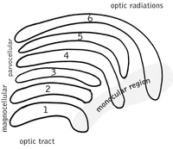

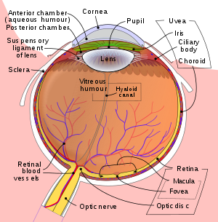

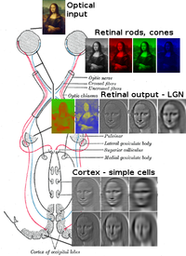

Above image shows that processing of the getting optical output from the simple cells.

Image Processing Can done by many techniques and methods. But now we will done using the openCV.

What exactly is openCV…?

OpenCV (Open Source Computer Vision Library) is released under a BSD license and hence it’s free for both academic and commercial use. It has C++, Python and Java interfaces and supports Windows, Linux, Mac OS, iOS and Android. OpenCV was designed for computational efficiency and with a strong focus on real-time applications. Written in optimized C/C++, the library can take advantage of multi-core processing. Enabled with OpenCL, it can take advantage of the hardware acceleration of the underlying heterogeneous compute platform.

Adopted all around the world, OpenCV has more than 47 thousand people of user community and estimated number of downloads exceeding 14 million. Usage ranges from interactive art, to mines inspection, stitching maps on the web or through advanced robotics.

How Computer Store Images?

OpenCV uses RBG color space by default.

Each Pixel coordinate (x, y) contains 3 values ranging for intensities 0 to 255(8-bit).

* Red
* Green
* Blue

Mixing different intensities of each color gives us the full color spectrum.

* **Example** :- Yellow
  + **Red** – 255
  + **Green** – 255
  + **Blue** – 0

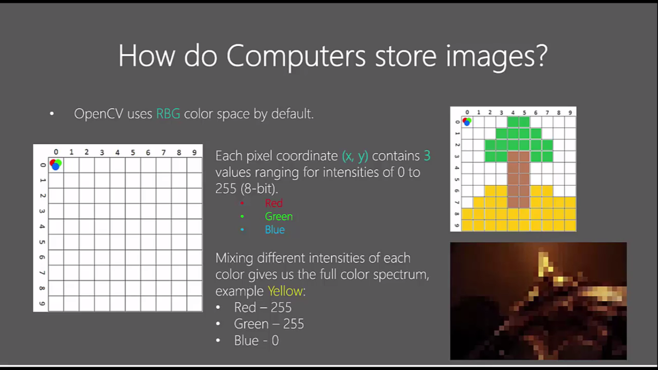

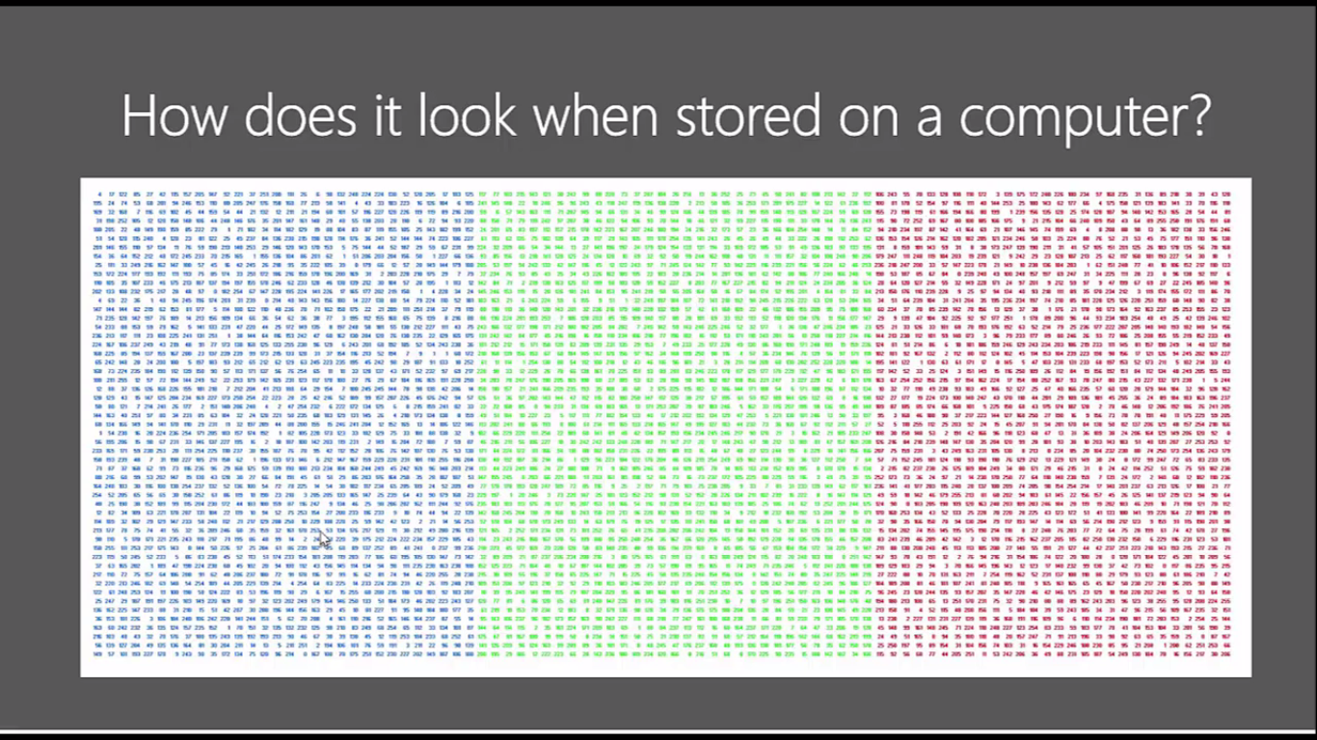

Images Are Stored In multi-dimensional arrays.

Black and White images are stored in 2-Dimensional arrays.

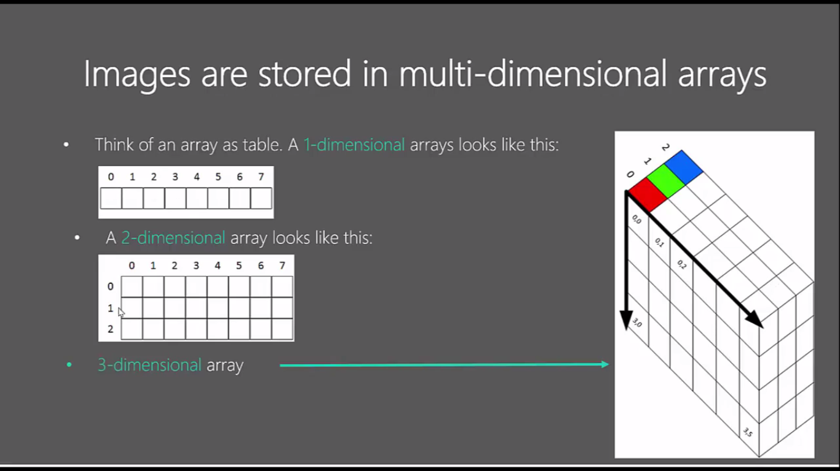

There are two types of B&W images.

* **Greyscale:** ranges of shades of grey
* **Binary:** pixels are either black or white

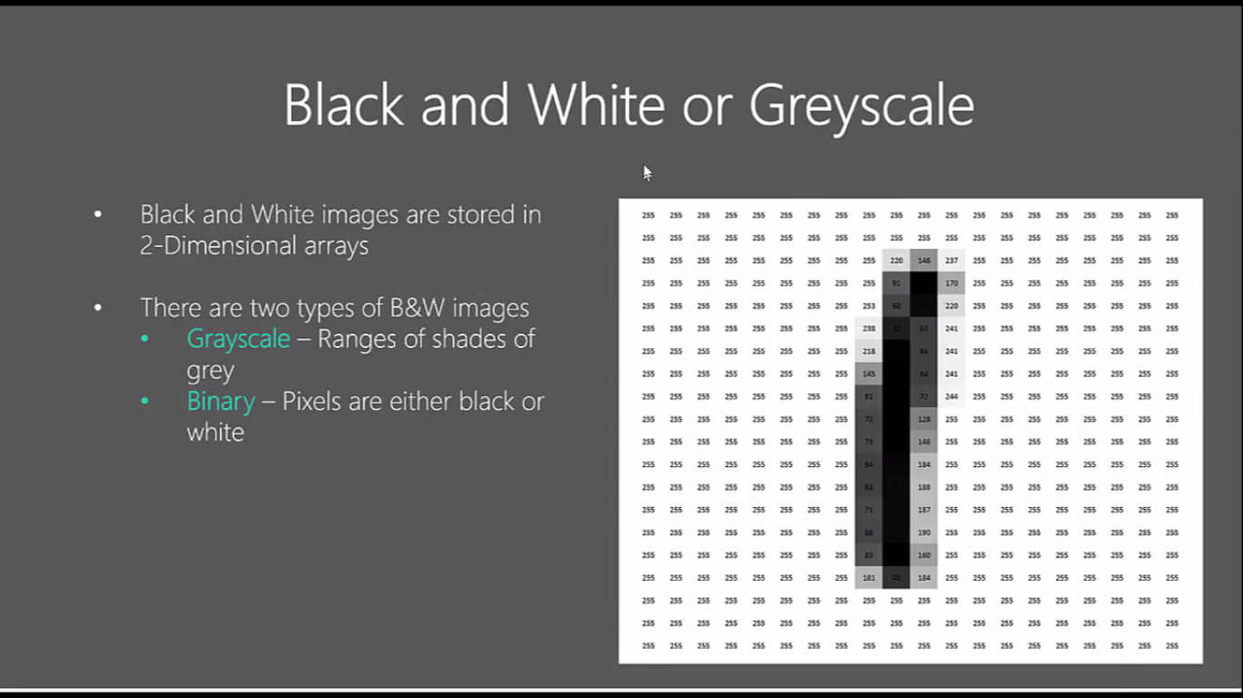

Default color is RGB but it actual store in the BGR format.

Jupyter Editor Demo:

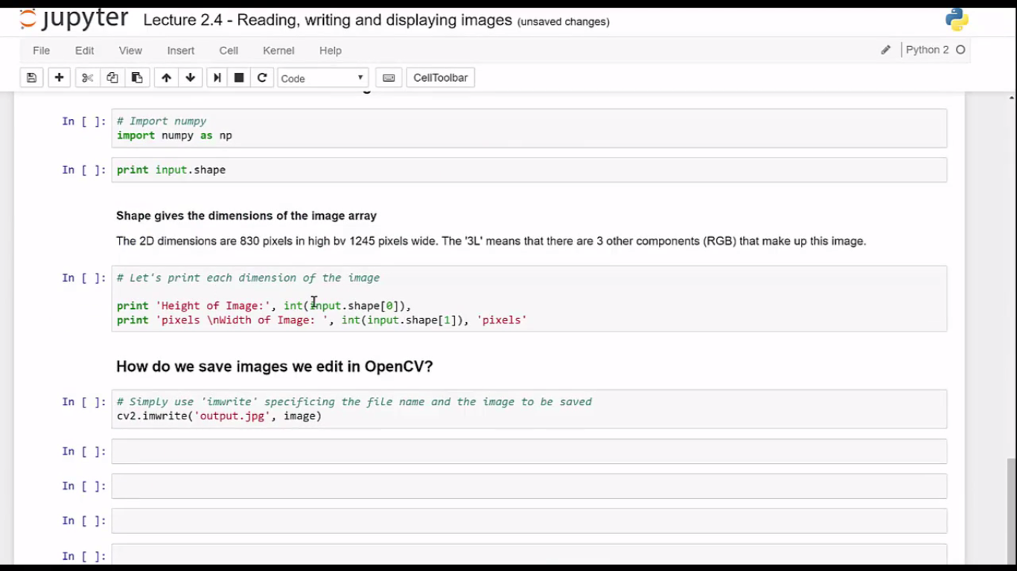

Grey Scaling: grey scaling is process by which an image is converted from a full color to shades to grey (black & white):

In OpenCV, Many Functions grayscale images before processing. This is done because it simplifies the image, acting almost as a noise reduction and increasing processing time as there is less information in the image.

Greyscaling Process:

Original Image:

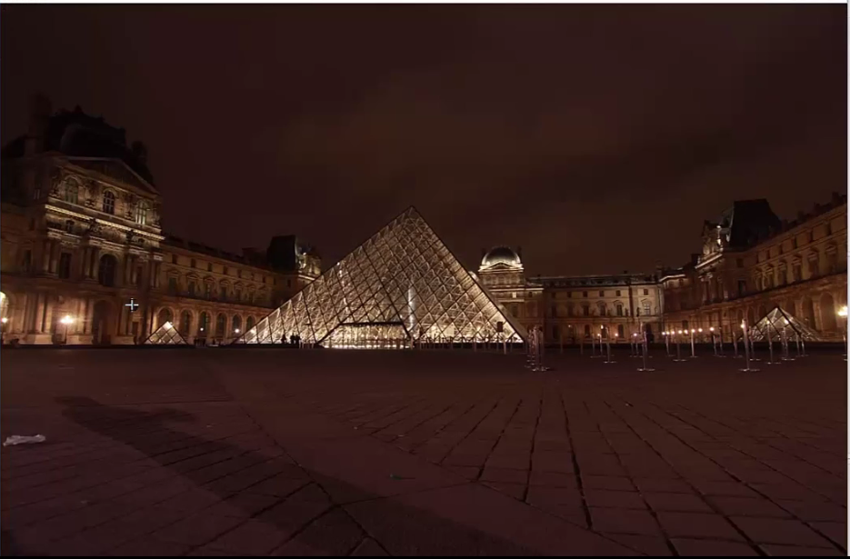

Output Image:

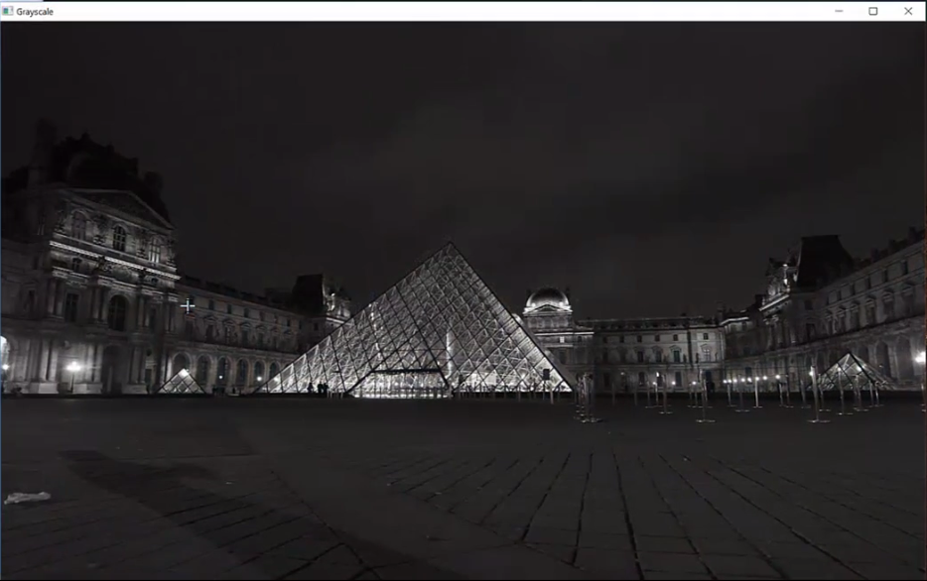

**HSV Color Space:**

**H**ue, **S**aturation, and **V**alue (**HSV**) is a color model that is often used in place of the RGB color model in graphics and paint programs. In using this color model, a color is specified then white or black is added to easily make color adjustments. HSV may also be called HSB (short for hue, saturation and brightness).it stores the color information in a cylinder representation.

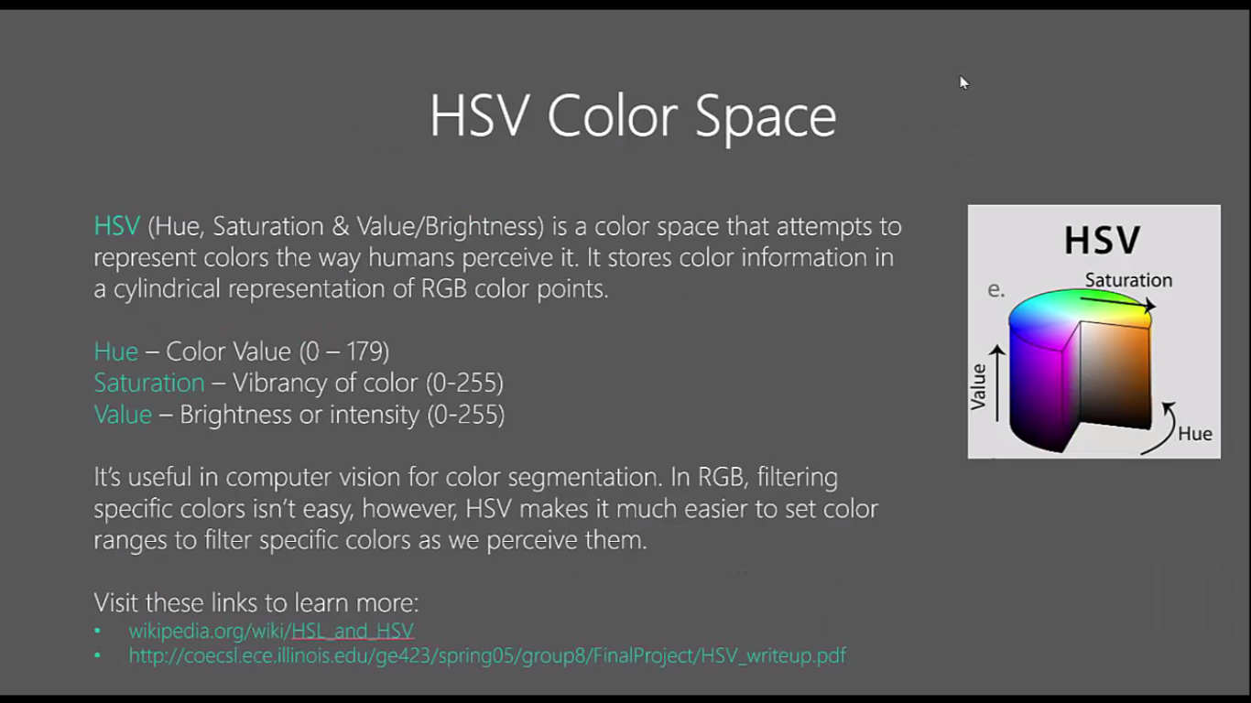

**Color Filtering**:-

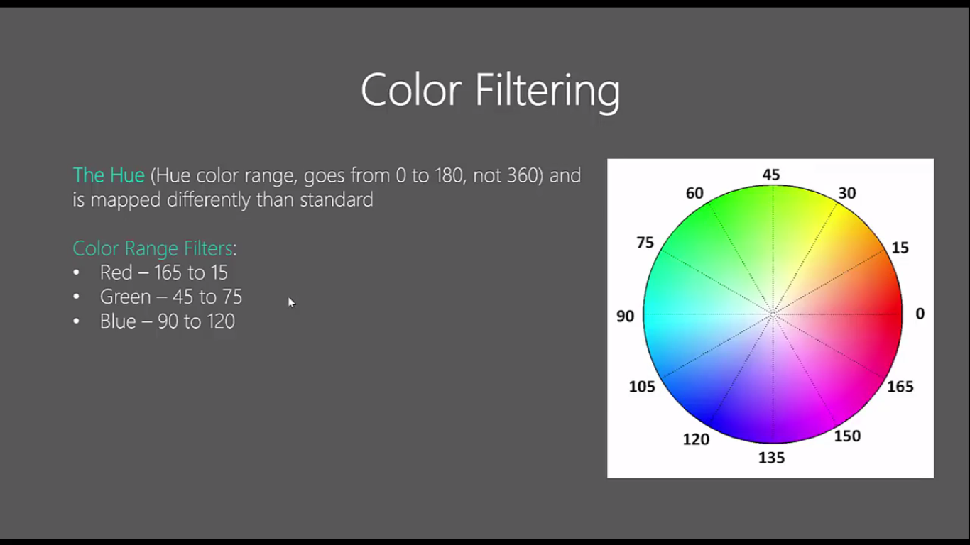

**Hue Channel:**

Looking at the below image shows that image is quite dark.

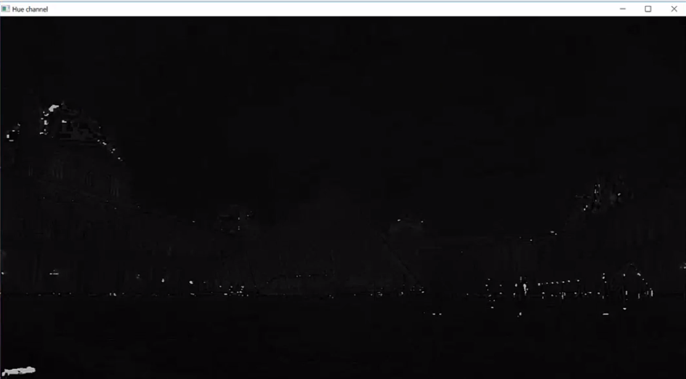

**Value Channel:**

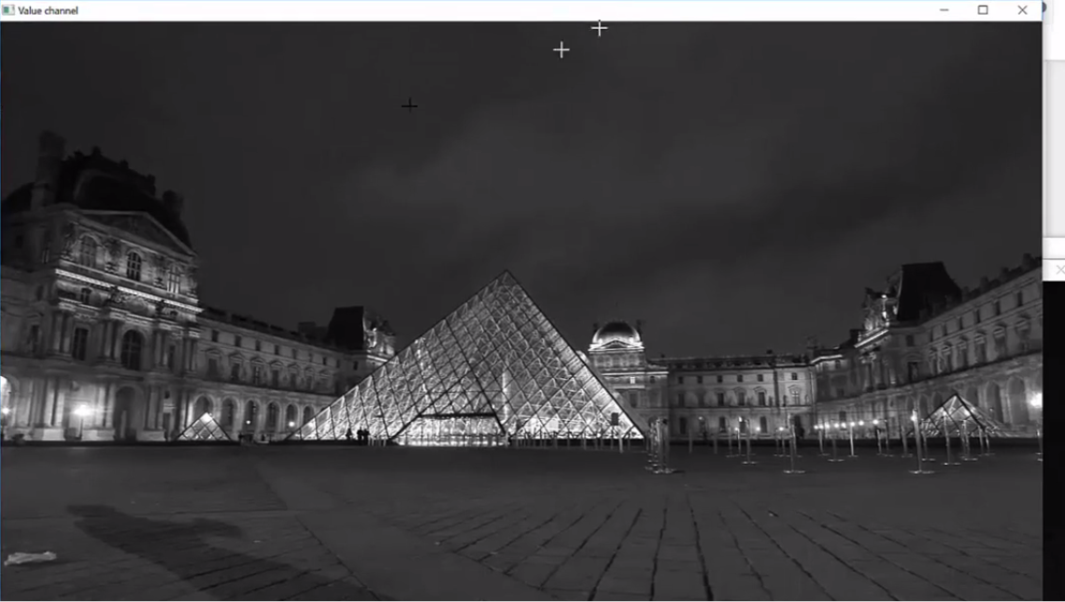

**Saturation Image:**

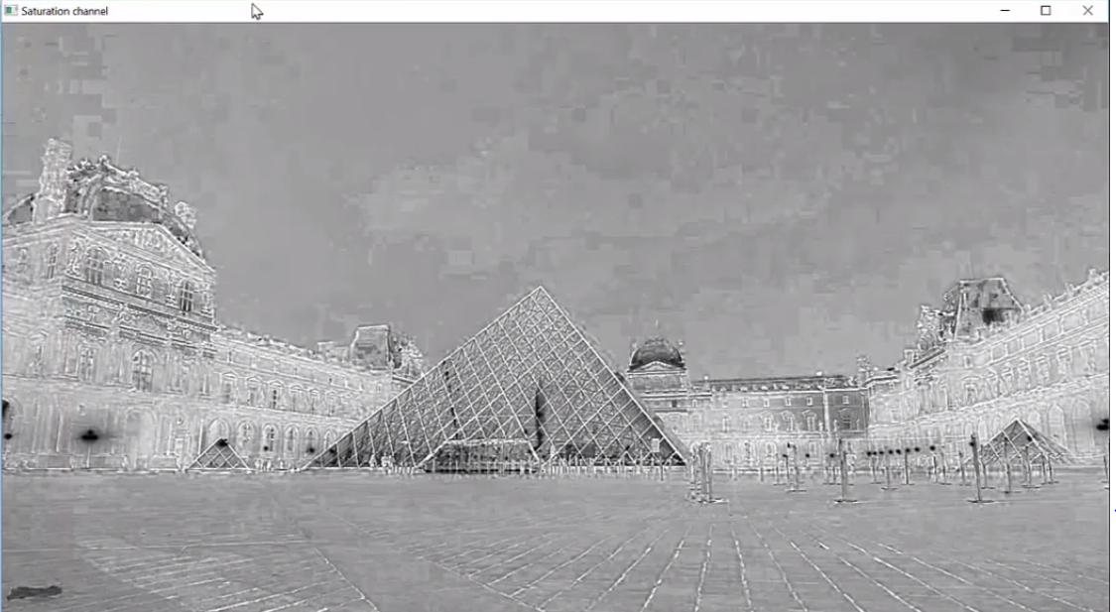

**Histogram:-**

A histogram is a great tool for quickly assessing a probability distribution that is intuitively understood by almost any audience. Python offers a handful of different options for building and plotting histograms. Most people know a histogram by its graphical representation, which is similar to a bar graph:

[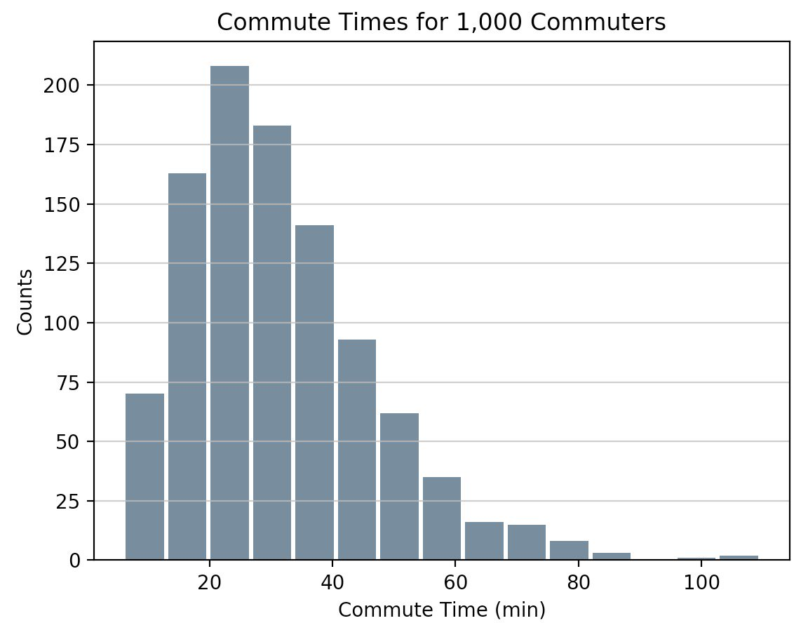](https://files.realpython.com/media/commute_times.621e5b1ce062.png)

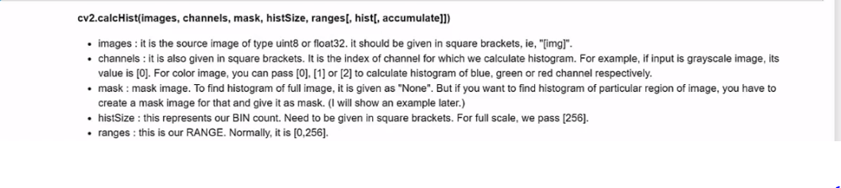

## **Image Blurring (Image Smoothing)**

Image blurring is achieved by convolving the image with a low-pass filter kernel. It is useful for removing noises. It actually removes high frequency content (eg: noise, edges) from the image. So edges are blurred a little bit in this operation. (Well, there are blurring techniques which doesn't blur the edges too). OpenCV provides mainly four types of blurring techniques.

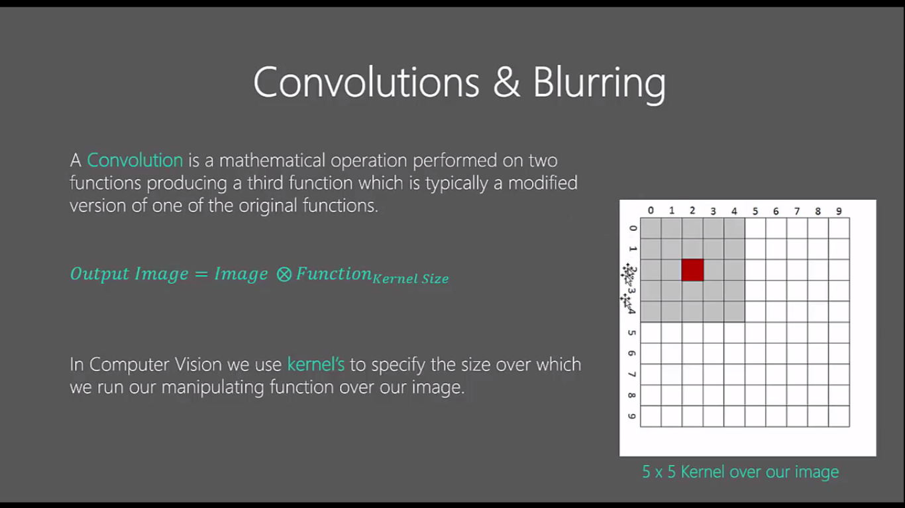

### 

### **Averaging**

This is done by convolving image with a normalized box filter. It simply takes the average of all the pixels under kernel area and replace the central element. This is done by the function **cv2.blur()** or **cv2.boxFilter()**.We should specify the width and height of kernel.

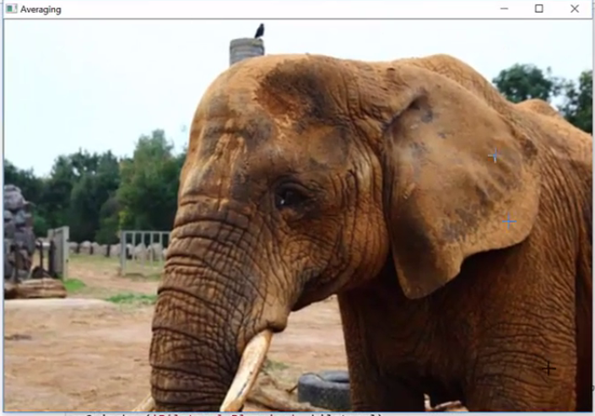

### **Gaussian Blurring**

In this, instead of box filter, gaussian kernel is used. It is done with the function, **cv2.GaussianBlur()**. We should specify the width and height of kernel which should be positive and odd. We also should specify the standard deviation in X and Y direction, sigmaX and sigmaY respectively. If only sigmaX is specified, sigmaY is taken as same as sigmaX. If both are given as zeros, they are calculated from kernel size. Gaussian blurring is highly effective in removing gaussian noise from the image.

If you want, you can create a Gaussian kernel with the function, **cv2.getGaussianKernel()**.

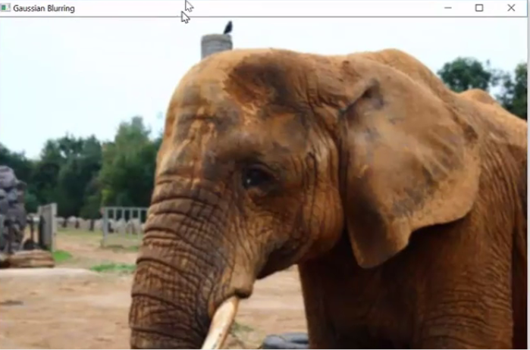

### **Median Blurring**

Here, the function **cv2.medianBlur()** takes median of all the pixels under kernel area and central element is replaced with this median value. This is highly effective against salt-and-pepper noise in the images. Interesting thing is that, in the above filters, central element is a newly calculated value which may be a pixel value in the image or a new value. But in median blurring, central element is always replaced by some pixel value in the image. It reduces the noise effectively. Its kernel size should be a positive odd integer.

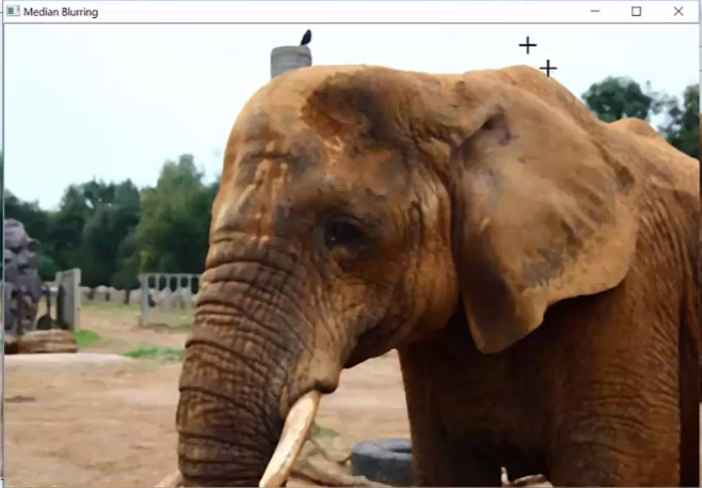

### **Bilateral Filtering**

**cv2.bilateralFilter()** is highly effective in noise removal while keeping edges sharp. But the operation is slower compared to other filters. We already saw that gaussian filter takes the a neighbourhood around the pixel and find its gaussian weighted average. This gaussian filter is a function of space alone, that is, nearby pixels are considered while filtering. It doesn't consider whether pixels have almost same intensity. It doesn't consider whether pixel is an edge pixel or not. So it blurs the edges also, which we don't want to do.

Bilateral filter also takes a gaussian filter in space, but one more gaussian filter which is a function of pixel difference. Gaussian function of space make sure only nearby pixels are considered for blurring while gaussian function of intensity difference make sure only those pixels with similar intensity to central pixel is considered for blurring. So it preserves the edges since pixels at edges will have large intensity variation.

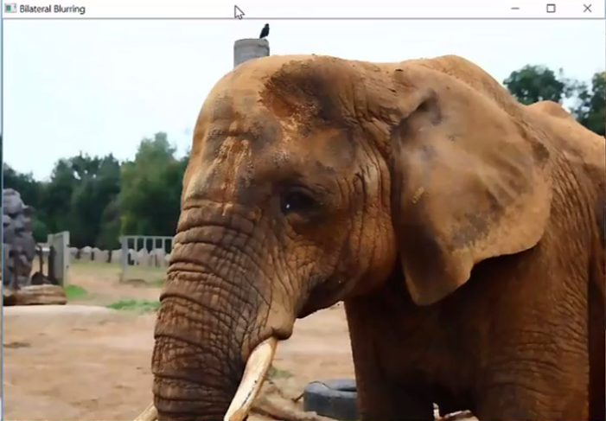

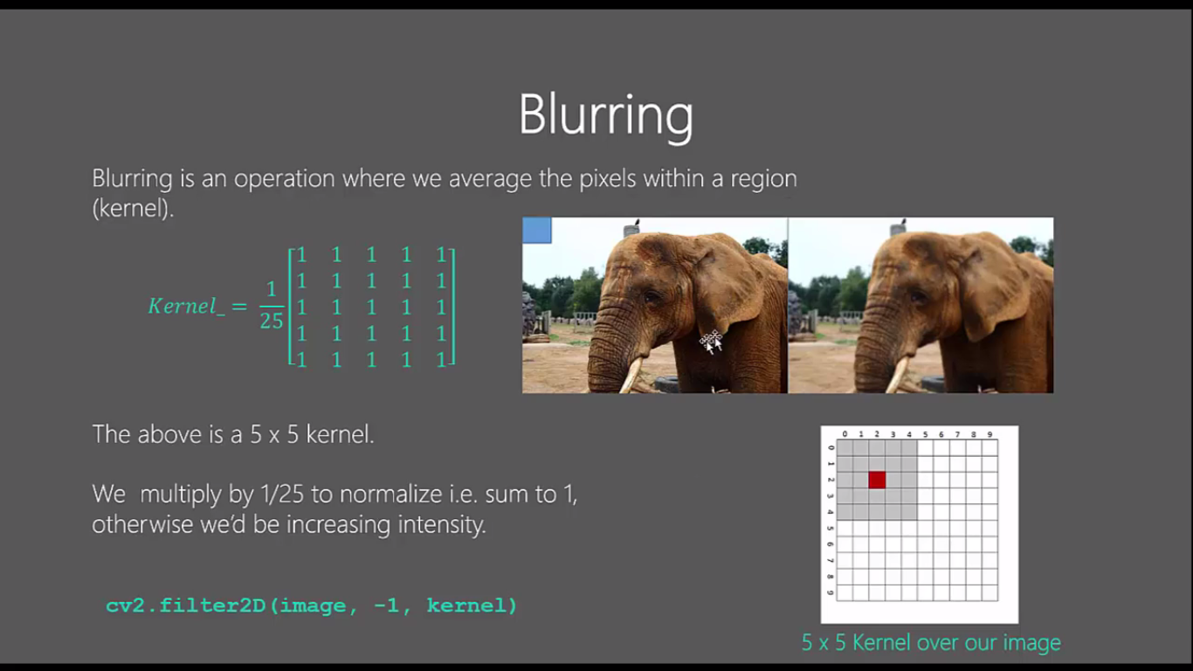

**Image Thresholding:**

Here, the matter is straight forward. If pixel value is greater than a threshold value, it is assigned one value (may be white), else it is assigned another value (may be black). The function used is **cv2.threshold**. First argument is the source image, which **should be a grayscale image**. Second argument is the threshold value which is used to classify the pixel values. Third argument is the maxVal which represents the value to be given if pixel value is more than (sometimes less than) the threshold value. OpenCV provides different styles of thresholding and it is decided by the fourth parameter of the function. Different types are:

* cv2.THRESH_BINARY
* cv2.THRESH_BINARY_INV
* cv2.THRESH_TRUNC
* cv2.THRESH_TOZERO
* cv2.THRESH_TOZERO_INV

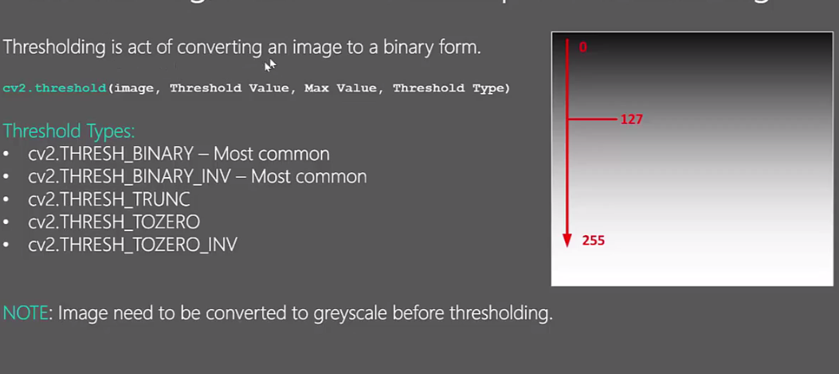

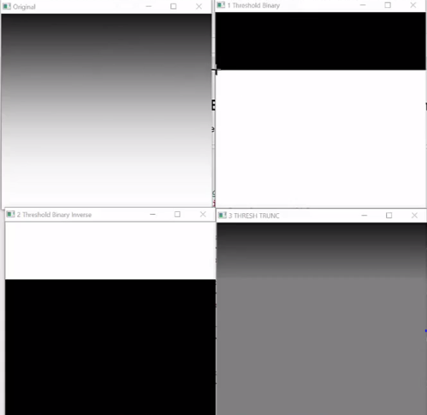

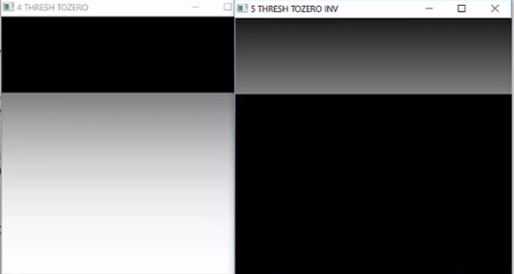

**Adaptive Thresholding:**

In the previous , we used a global value as threshold value. But it may not be good in all the conditions where image has different lighting conditions in different areas. In that case, we go for adaptive thresholding. In this, the algorithm calculate the threshold for a small regions of the image. So we get different thresholds for different regions of the same image and it gives us better results for images with varying illumination.

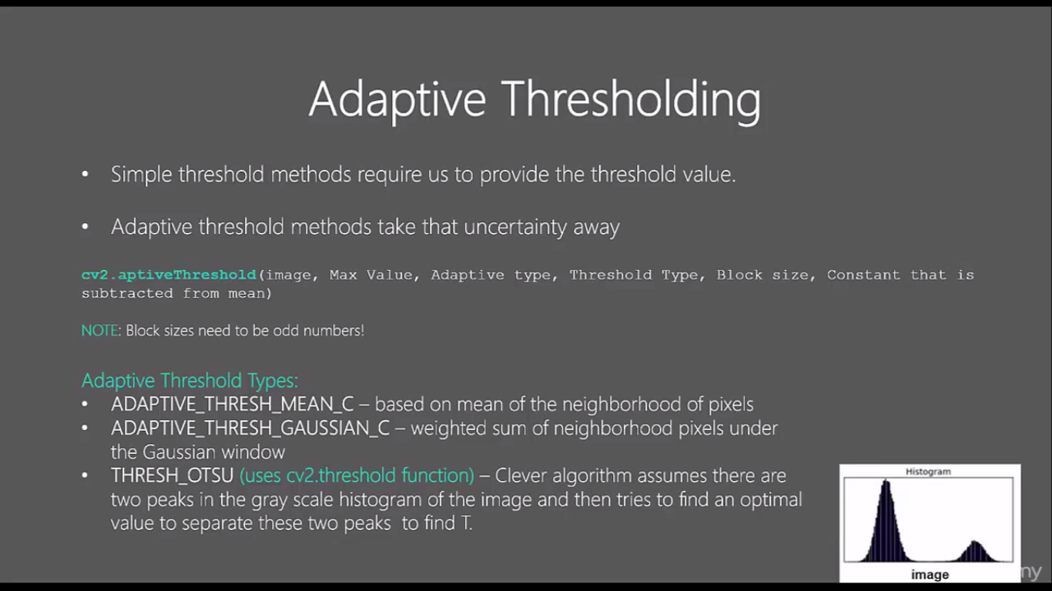

It has three ‘special’ input params and only one output argument.

**Adaptive Method** - It decides how thresholding value is calculated.

* cv2.ADAPTIVE_THRESH_MEAN_C : threshold value is the mean of neighborhood area.
* cv2.ADAPTIVE_THRESH_GAUSSIAN_C : threshold value is the weighted sum of neighborhood values where weights are a gaussian window.

**Block Size** - It decides the size of neighborhood area.

**Erosion and Dilation of images**

**Basics of Erosion:**

* Erodes away the boundaries of foreground object
* Used to diminish the features of an image.

**Working of erosion:**

1. A kernel(a matrix of odd size(3,5,7) is convolved with the image.
2. A pixel in the original image (either 1 or 0) will be considered 1 only if all the pixels under the kernel is 1, otherwise it is eroded (made to zero).
3. Thus all the pixels near boundary will be discarded depending upon the size of kernel.
4. So the thickness or size of the foreground object decreases or simply white region decreases in the image.

**Basics of dilation:**

* Increases the object area
* Used to accentuate features

**Working of dilation:**

1. A kernel(a matrix of odd size(3,5,7) is convolved with the image
2. A pixel element in the original image is ‘1’ if at least one pixel under the kernel is ‘1’.
3. It increases the white region in the image or size of foreground object increases

**Feature Detection Algorithms:-**

**SIFT (Scale-Invariant Feature Transform):-**

in 2004, **D.Lowe**, University of British Columbia, came up with a new algorithm, Scale Invariant Feature Transform (SIFT) in his paper, **Distinctive Image Features from Scale-Invariant Key points**, which extract key points and compute its descriptors.

**sift.detect()** function finds the keypoint in the images. You can pass a mask if you want to search only a part of image. Each keypoint is a special structure which has many attributes like its (x,y) coordinates, size of the meaningful neighbourhood, angle which specifies its orientation, response that specifies strength of keypoints etc.

OpenCV also provides **cv2.drawKeyPoints()** function which draws the small circles on the locations of keypoints. If you pass a flag, **cv2.DRAW_MATCHES_FLAGS_DRAW_RICH_KEYPOINTS** to it, it will draw a circle with size of keypoint and it will even show its orientation.

**SURF (Speeded-Up Robust Features):-**

it was comparatively slow and people needed more speeded-up version. In 2006, three people, Bay, H., Tuytelaars, T. and Van Gool, L, published another paper, “SURF: Speeded Up Robust Features” which introduced a new algorithm called SURF. As name suggests, it is a speeded-up version of SIFT.

In SIFT, Lowe approximated Laplacian of Gaussian with Difference of Gaussian for finding scale-space. SURF goes a little further and approximates LoG with Box Filter.

You initiate a SURF object with some optional conditions like 64/128-dim descriptors, Upright/Normal SURF etc. All the details are well explained in docs. Then as we did in SIFT, we can use SURF.detect(), SURF.compute() etc for finding keypoints and descriptors.

**FAST Algorithm for Corner Detection**

FAST (Features from Accelerated Segment Test) algorithm was proposed by Edward Rosten and Tom Drummond in their paper “Machine learning for high-speed corner detection” in 2006 (Later revised it in 2010)

It is called as any other feature detector in OpenCV. If you want, you can specify the threshold, whether non-maximum suppression to be applied or not, the neighborhood to be used etc.

For the neighborhood, three flags are defined, cv2.FAST_FEATURE_DETECTOR_TYPE_5_8, cv2.FAST_FEATURE_DETECTOR_TYPE_7_12 and cv2.FAST_FEATURE_DETECTOR_TYPE_9_16.

**Identification Using Haar Cascade**

Object Detection using Haar feature-based cascade classifiers is an effective object detection method proposed by Paul Viola and Michael Jones in their paper, “Rapid Object Detection using a Boosted Cascade of Simple Features” in 2001. It is a machine learning based approach where a cascade function is trained from a lot of positive and negative images. It is then used to detect objects in other images.

Initially, the algorithm needs a lot of positive images (images of faces) and negative images (images without faces) to train the classifier. Then we need to extract features from it.

OpenCV comes with a trainer as well as detector. If you want to train your own classifier for any object like car, planes etc. you can use OpenCV to create one. Its full details are given here: Cascade Classifier Training.